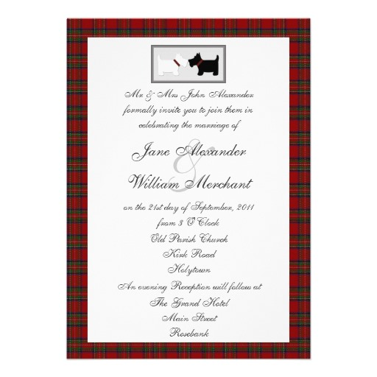

**Burns Night 2015**

**£19.95**

Smoked Salmon Gravalax with Horseradish and Oatcakes

Cock a Leekie Soup with Wholemeal Bread and Parsley Butter (V option available)

Venison Hash topped with a Soft Poached Egg

Sorbet

Traditional Haggis, Neeps, Tatties and Whiskey Sauce (V option available)

Wild Mushroom Kedgiree

Juicy, Whiskey, Creamy Highland Mussels

Marmalade and Whiskey Bread and Butter Pudding

Clootie Dumpling

Raspberry Cranachan

£19.95