All Saints’ Church, Minstead
Notices for the week commencing 22nd January, 2017

SERVICES
Sunday, 22nd Jan: 10.30 - Service of the Word - led by Hilary with a talk by Nigel.
Sides are Karen and Eileen.
Michele, Eileen and Ben are reading.

Sunday, 29th Jan: 10.30 - Service of Worship and Music

NEWS
Tuesday, 24th Jan: 10am - PCC Standing Committee

CHARITY GIVING
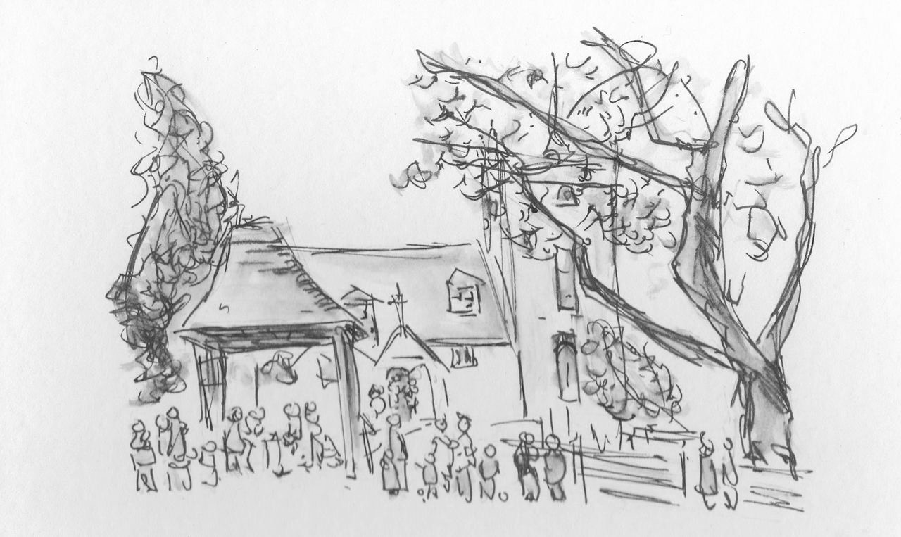
During January and February we are supporting the Minstead Trust. Please make your donations in the charity dish by the door. More information available in church.
Church Wardens
Isabel Yeo 02380 282724
Elizabeth Randall 02380 811115

http://www.facebook.com/MinsteadChurch

http://newforestparishes.com

We are remembering those less fortunate than ourselves. The New Forest Basics Bank aims to provide support and help to families and individuals in need. The collection box is by the font. You are welcome to bring donations of non perishable food and hygiene items whenever the church is open.

Liz
Isabel

