All Saints’ Church, Minstead
Notices for the week commencing 29th January, 2017

SERVICES
Sunday, 29th Jan: 10.30 - Service of Worship and Music led by Isabel.
Sunday, 5th February: 9.30 - Holy Communion

EVENTS
PCC meeting on 1st Feb at 7.30.

Thursday, 2nd Feb at 7.30 - Home Group at AS
Tuesday, 1st Feb at 12.00 - Noon Prayer
Fridays from 3 - 5: Kneeler Group. (Please see Liz if interested in joining)

CHARITY GIVING
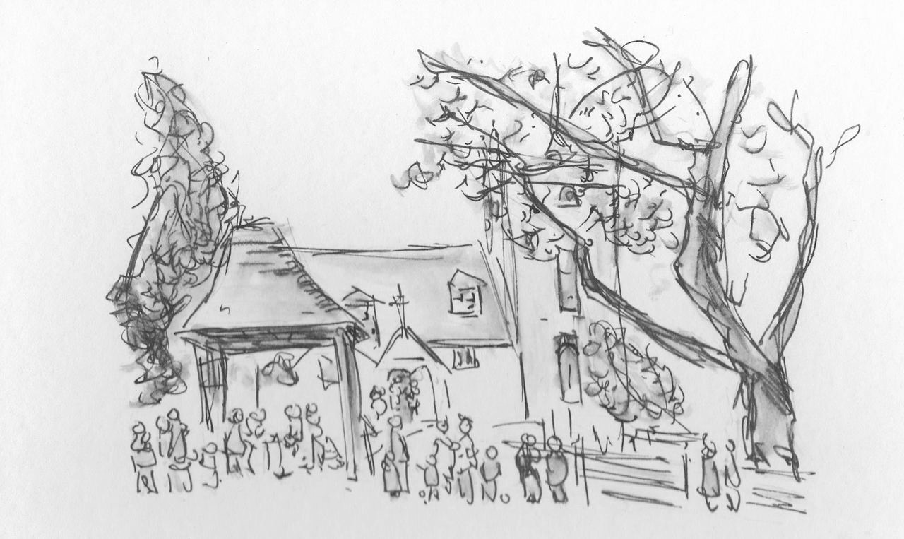
During January and February we are supporting the Minstead Trust. Please make your donations in the charity dish by the door. More information available in church.
Church Wardens
Isabel Yeo 02380 282724
Elizabeth Randall 02380 811115

http://www.facebook.com/MinsteadChurch

http://newforestparishes.com

We are remembering those less fortunate than ourselves. The New Forest Basics Bank aims to provide support and help to families and individuals in need. The collection box is by the font. You are welcome to bring donations of non perishable food and hygiene items whenever the church is open.

Liz Randall
Isabel Yeo
(Churchwardens)

