All Saints’ Church, Minstead  Notices for the week commencing  5th March 2017 | Church Wardens  Isabel Yeo 02380 282724  Elizabeth Randall 02380 811115  http://www.facebook.com/MinsteadChurch
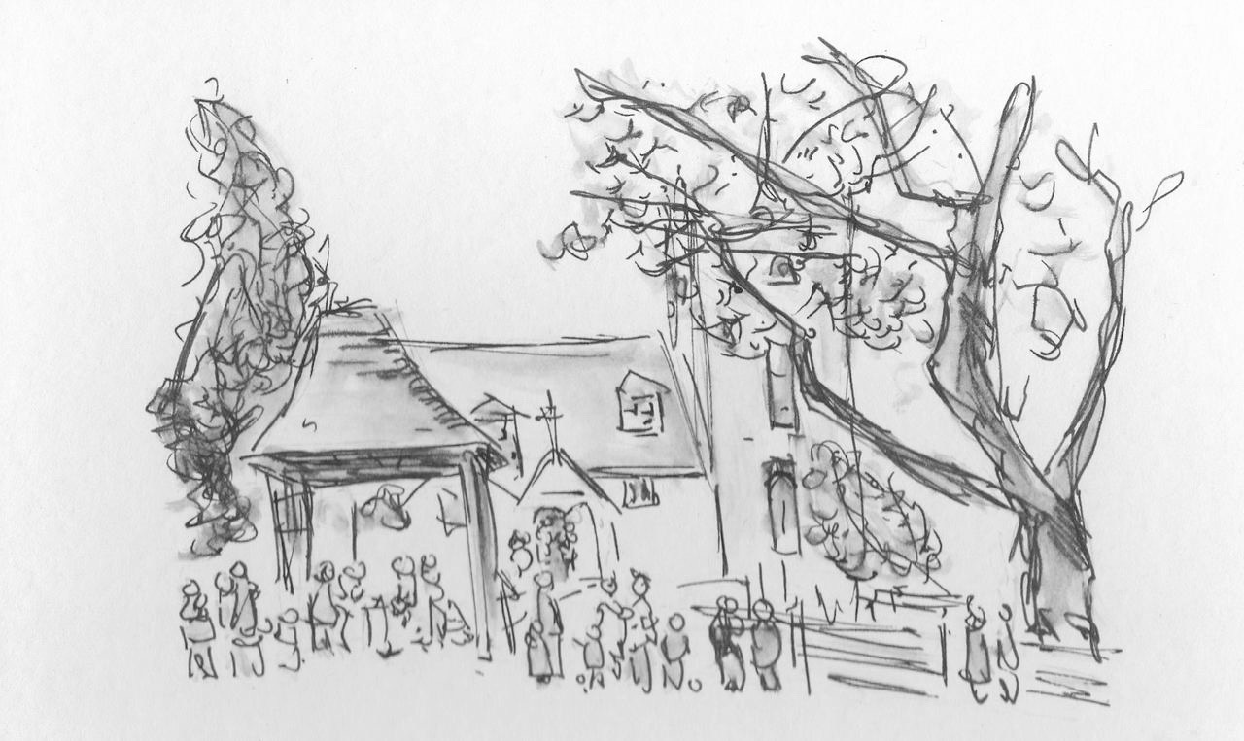

SERVICES
Sunday 5th, 9.30 - Morning Worship and Christening. The service will be led by James. Sides are Marian and Fiona, Kelvin is duty Church Warden and will also lead the intercessions. Terry Randall and Michelle Arkel will be giving the Readings
Sunday 12th, 6pm - Evensong with Holy Communion.
NEWS
Sunday 12th, 4.15pm - Discussion Group and tea. Or "Tea and Talk" if you'd rather! You're welcome to join in.
The Lent Group is meeting instead of Home Group on Thursday evenings, 7.30 in the Compton Area of the church.. The book being studied is "Let me Go There" by Paula Gooder. You're welcome to join in. Michael, Karen or Nick will be happy to explain a little more.
Sunday 26th at 10.30 - Mothering Sunday service! More later.
Compton Area Exhibition of stunning paintings by a local artist. They are amazing, make sure you take a look.
CHARITY GIVING
During March and April this church is supporting Mukinge Hospital in Zambia. After services, you can make your donations using the special collection dish, which will be either at the church door or in the Compton area. More information available in church.
Lyndhurst Deanery Lent Appeal. Prayer and resources for Rwanda; there is a poster in the porch and some handouts near the door.
Don't forget when you're shopping - Basics Bank. Please remember all those less fortunate than ourselves... New Forest Basics Bank aims to provide support and help to individuals and families in need. There is a collecting box in church, You are welcome to bring donations of non perishable food and hygiene items whenever the church is open.

Elizabeth Randall (02380 811115)  Isabel Yeo (02380 282724)  Churchwardens,  All Saints' Church, Minstead | https://www.facebook.com/MinsteadChurch  http://newforestparishes.com/  http://newforestparishes.com/about/minstead-church/calendar-2/

