

NORTHERN NEW FOREST
Monthly Beat Report –
February 2017

Hello and welcome to February’s Beat Report for the Northern New Forest. I am PCSO 14495
Richard Williams, one of the Beat Officers for this area, and I am based at Lyndhurst Police
Station with my colleague PC Steven Norris.

Beat Surgeries

Please come and meet your Beat Officers, PC 20127 Steven NORRIS and PCSO 14495 Richard WILLIAMS. In March we will be at
Bramshaw Village Shop on Monday 27th March at 8am.
Bartley Post Office on Monday 27th March at 9am.
Minstead Village Shop on Saturday 11th March at 10am.
St Michael and All Angels Church in Lyndhurst on Sunday 12th March at 10.30am.
Lyndhurst Baptist Church on Sunday 12th March at 11.30am.
Lyndhurst Roman Catholic Church on Sunday 19th March at 10.00am.
Colbury Parish Church on Deer Leap Lane in Colbury on Sunday 19th March at 11.00am.



Hampshire Alerts – recently PC NORRIS and I have been visiting the farms and other rural properties on the Beat and encouraging the residents to register with Hampshire Alerts. Our plan is to encourage as many of you as possible to tell us about the suspicious activity you witness. We can then pass that information on to the rest of the Beat so that everyone knows what people and which vehicles are up to no good. This month over 30 suspicious people and vehicles have been reported to us and by signing up to Hampshire Alerts you will be told about any suspicious activity that could stop you becoming a victim of crime. It’s a system that works all over the country and it’s free. To register please go to: www.hampshirealert.co.uk

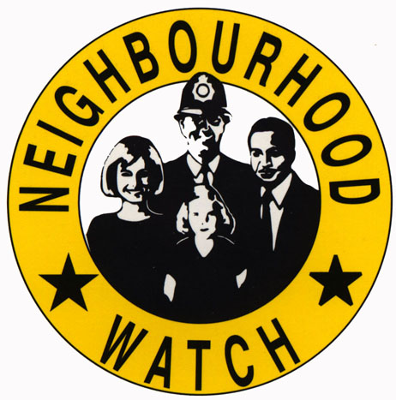

Also this month, two new Neighbourhood Watch schemes have been set up in Copythorne and Cadnam. Neighbourhood Watch is a really affective way of helping to keep the community you live in safe from crime, and can also support the vulnerable people who live in your Neighbourhood. If you would like more information about starting a scheme where you live, email me and I can send you all the details.

Since our last report we have had the following incidents reported to us.

Burglaries and Non Dwelling Burglaries:
February has seen 3 houses burgled, two in Cadnam and one in Lyndhurst, and again both during the daytime. There has been one Non Dwelling burglaries this month. That happened during the day in Ower and again power tools were stolen from a garage. Can I ask that you register the details of all of your valuable property for free on www.immobilise.com. Hopefully you will never become the victim of a crime, but if you do and your property is stolen then immobilise can help us return it to you.

Theft from vehicle:
There have been 11 cars broken into this month, with the car parks targeted being the Canadian War Memorial, Bolderwood, Andrews Mare and Millyford Bridge. As the weather improves, thieves who target vehicles left in Forest car parks become more and more active. They will only break into vehicles that have valuables left on show and that includes anything hidden under seats or coats or blankets. And in some cases the thieves will watch while people put their valuables in the boot before going for their walk. The only way to ensure that you don’t become a victim is to take everything valuable with you and leave nothing on show in your vehicle. And please tell your families and friends who also us the New Forest to do the same. Thank you.

The other thefts happened at businesses and farm yards in the Woodlands, Cadnam and Bartley areas, and all involved diesel or petrol being taken from unattended vehicles. If you do have vans or tractors or other farm machinery that is left unattended, especially overnight please leave as little fuel in them as possible, and leave a note on your vehicle explaining that. This has worked in many cases where farm vehicles have been repeatedly targeted.

Other Incidents of notes:

The MACE convenience store on Southampton road at the Bartley crossroads was targeted again this month. While the shop was still open a large quantity of cigarettes and alcohol were stolen. Investigations are ongoing and it’s hoped that arrests will be made soon. In Winsor, a single plant pot was stolen from a front garden, and a brick has been thrown through the windscreen of a car that was parked on a driveway in Winsor. And a bicycle has been stolen from the front garden of a house in Ashurst. The owner only left it alone for a short time, but it was still taken so please keep your possessions with you or locked at all times.

In February 26 motorists have been caught speeding in Lyndhurst, Cadnam, Ashurst and Brook, 2 drivers have been arrested in Woodlands and Ashurst for being over the drink drive limit, 3 cars have been seized for having no tax, mot or insurance, and a fine has been issued to a man who was caught using his motorbike off road in the New Forest around the Acres Down Farm and Andrews Mare car park areas

Thank you again for all the calls made to the Police in January about the suspicious people and vehicles you have seen in the Northern New Forest. Please keep those calls coming. You can call 101 or if you prefer you can call PC NORRIS or myself PCSO WILLIAMS directly. If there is no answer then that means we are on a rest day, so either leave us a message or send us an email. And remember if you are telling us about a vehicle, the most useful information you can give us is the registration number. You are our eyes and ears in your community and we value any information you can give us that will help us keep the places where you live safe.

steven.norris@hampshire.pnn.police.uk
07554 775477
richard.williams@hampshire.pnn.police.uk
07554 775469


