Fully socialised and loving dog needs new home
A True Story
By Chris and Tessa Keeley
Just over a week ago, one of our beloved German Shepherds died unexpectedly. He went to the vet for an x-ray and, whilst sedated, had a heart attack. He was only 5. Our other shepherd started pining and lost interest in food and walks and was clearly suffering the loss as much as we were, so we actively began searching to find him a new mate.
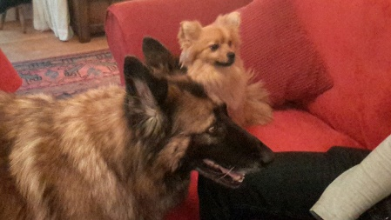
Last week we were introduced to a young army tank driver who, following a terrible accident, is being discharged from the army. He is only 22 years old but we were struck by how responsible and mature he and his wife were. As he is losing his home and job and given their futures are so uncertain, they have decided to rehome their pets - a German Shepherd called Charlie and a Pomeranian called Foxy.

We jumped at the chance of taking on the Shepherd after the owner had vetted us rigorously, asked to see photo ID, spent a whole day here and asked a lot of very mature and searching questions. He has left a great impression on us and, as he is an injured soldier, we would like to help him if we can. We have taken the Shepherd who came to us well trained and socialised with a stable, loving personality and settled in immediately.
We would love to find the Pomeranian a home in the vicinity so he can continue to see the Shepherd. We would also be open to taking the dog while a future owner went on holiday, from time to time, if it would help. We have thought long and hard about taking this dog ourselves, but do not feel it would be fair as with three dogs (like three children) one can often be 'left out’.

The owners have written the following about Foxy ...
Meet Foxy. He has such a one in a million personality and we are devastated to have to give him up but due to personal circumstances we can no longer afford to keep him. He is up to date with his vaccinations, flea and worming treatments. He has also been neutered and microchipped and will come with all documents we have for him and 3 months of Flea and Wormer.
He can bark if he is unhappy but he loves a good cuddle and is very playful. He loves to be picked up and cradled like a baby. He would suit old kids (over 7 years) as he does like his own space. He is good with other dogs and cats (as the photos show) and has been living with a Shepherd and a young cat. His favourite treats are cucumber and carrots but well he will eat almost anything else that you give him.
He is still a young dog and truly acts it sometimes. He loves his Pink Teddy which he will bring with him. He is slightly overweight and therefore is on Doggie Diet food which he will most likely be on for most of his life as he tends to put on weight as soon as he comes off of it.
He is cheeky and very funny at times he will make a great companion for someone who has the time to give him a forever home. We would want to stay in touch with new owners and will request to do a home visit before we let him go. Also we will ask you to present ID when first coming to view him in our home, along with proof of address. If you, or anyone you know, is interested in meeting Foxy, in the first instance please contact: Chris and Tessa Keeley - 07958 727369 / tessakeeley@btconnect.com

