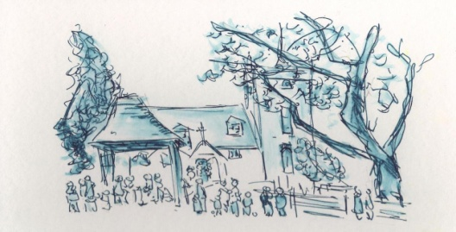
All Saints' Church, Minstead:
Notices - week commencing Sept 10th, 2017.

SERVICES
September 10th - 6pm , Evensong.
September 17th-9.30am, Holy Communion.

NEWS
Sun September 10th - 4.15, Discussion Group begins again. Tea and delicious cake, plus a chance to explore topical subjects for an hour. You're invited to stay on for Evensong!

Wed September 13th, 7.30pm at St Michael's - the PCCs of all three parishes will meet together with the Archdeacon to begin the process of finding a new incumbent for this Benefice.

Churchwarden. Isabel's term as Churchwarden will finish in the late spring of 2018. Someone is needed to work alongside Liz and support her in managing the life of the church and parish, especially during this time of change. Please do whilst consider carefully and prayerfully if your own gifts and talents could be used in the role.

Tower Repair work. As well as the deterioration in the roof timbers, it has been discovered that the louvre in the east wall of the tower needs to be completely replaced and the brickwork above the opening properly supported. The project will over run for a fortnight. Access arrangements remain the same.

Fundraising. Given that the PCC is in the process of spending £46,000 (a significant proportion of the funds available) on the tower work, it's vital now to have new energy and effort put into retrospective fundraising. Several useful ideas have been put forward and we need people to carry them forward. Please come and talk to the church wardens or the treasurer about this.
A display of photos of the work and the tower is in the Compton Area. Photos are also on the Facebook page.
Deanery Synod. Finance Chair is needed for the Lyndhurst Deanery Finance Committee. Would suit anyone with Accountancy skills. Six meetings a year in the Deanery (Lyndhurst/Waterside/Lymington area) Also liaison with the Diocesan offices, Winchester and 2 or 3 meetings with them a year. 1 annual set of accounts.

Compton Area Don't miss the photographic exhibition of New Forest Butterflies in the Compton Area, taken by Marian Young.
CHARITY GIVING During September and October, this church is supporting Tear Fund. After services, you can make your donations using the special collection dish, found either at the church door or in the Compton area. More information available in church.
Don't forget when you're shopping to buy something to donate to the Basics Bank. New Forest Basics Bank aims to provide support and help to individuals and families in need. The collecting box is in church. You are welcome to bring donations of non perishable food and hygiene items whenever the church is open.

