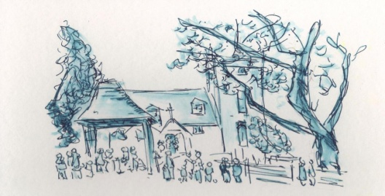
All Saints' Church, Minstead:
Notices - week commencing Sept 17th, 2017.

SERVICES
September 17th, 9.30am - Holy Communion.
September 24th, 10.30am - Harvest Festival.

NEWS
Wednesday 20th, 8pm in church - meeting of the PCC.
Sunday 24th; Harvest Festival.
- Service at 10.30; give thanks to God for the plenty enjoyed by many of us, whilst remembering those in need of basics. Please bring your gifts of non perishable foods & toiletries for the NF Basics Bank.
- 12 noon; "bring and share" lunch; all welcome. Please bring a plate of food to share and your own crockery, cutlery and glasses. If the forecast is fine, bring an outdoor chair. Tea, coffee & squash provided.
New incumbent. On Sept 13th, the 3 PCCs met with Archdeacon Peter to learn about the process. The first step along the way is to make a Benefice Profile; a mixture of images and text giving a realistic depiction of our benefice and communities. It will be the first impression seen by prospective candidates. Do speak to PCC members to find out more.
Churchwarden. Isabel's term as Churchwarden will finish in the late spring of 2018. Someone is needed to work alongside Liz; supporting her in managing the life of the church and parish, especially during this time of change. Please do whilst consider carefully and prayerfully which of your own gifts and talents could be used in the role.
Tower Repair work. As well as the deterioration in the roof timbers, it has been discovered that the louvre in the east wall of the tower needs to be completely replaced and the brickwork above the opening properly supported. The project is overrunning. Access arrangements remain the same.
Fundraising. Given that the PCC is in the process of spending £46,000 (a significant proportion of the funds available) on the tower work, it's vital now to have new energy and effort put into retrospective fundraising. Several useful ideas have been put forward and we need people to carry them forward. Please come and talk to the church wardens or the treasurer about this. A display of photos of the work and the tower is in the Compton Area. Photos are also on the FB page.
Deanery Synod. Finance Chair is needed for the Lyndhurst Deanery Finance Committee. Would suit anyone with Accountancy skills. Six meetings a year in the Deanery (Lyndhurst/Waterside/Lymington area) Also liaison with the Diocesan offices, Winchester and 2 or 3 meetings with them a year. 1 annual set of accounts.
Compton Area Photographic exhibition of New Forest Butterflies, taken by Marian Young.
CHARITY GIVING During September and October, this church is supporting Tear Fund. After services, you can make your donations using the special collection dish, found either at the church door or in the Compton area. More information available in church.
Don't forget when you're shopping to buy something to donate to the Basics Bank. New Forest Basics Bank aims to provide support and help to individuals and families in need. The collecting box is in church. You are welcome to bring donations of non perishable food and hygiene items whenever the church is open.

