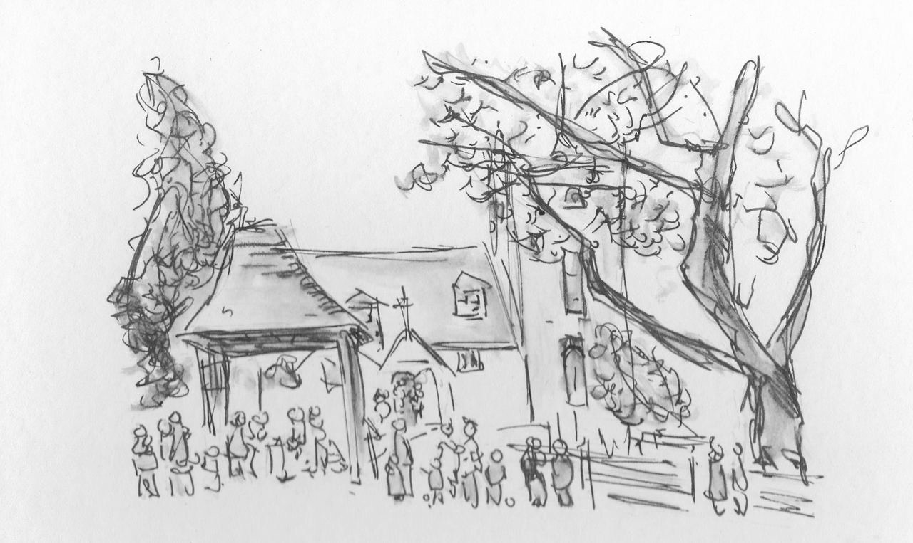
All Saints' Church, Minstead
Notices - week commencing Oct. 1st, 2017.

SERVICES

October 1st 9.30 Holy Communion
October 8th 4.15 Discussion Group
6.00 Evensong

NEWS
New incumbent. On Sept 13th, the 3 PCCs met with Archdeacon Peter to learn about the process. The first step along the way is to make a Benefice Profile, a mixture of images and text giving a realistic depiction of our benefice and communities. It will be the first impression seen by prospective candidates. We have 2 AS parish reps on the Benefice team and meetings should start this week.

Churchwarden. Isabel's term as Churchwarden will finish in spring of 2018. Someone is needed to work alongside Liz, supporting her in managing the life of the church from next year, when hopefully we will have a new vicar. Please do consider carefully and prayerfully which of your own gifts and talents could be used in the role.

Tower Repair work. Work on the tower should be completed within the week.

Fundraising. Given that the PCC is due to ay out £46,000 (a significant proportion of our funds) on the tower work, it's vital now to have new energy and effort put into fundraising. Several useful ideas have been put forward and we need people to carry them forward. Please come and talk to the church wardens or the treasurer about this. A display of photos of the work and the tower is in the Compton Area. Photos are also on the Facebook page.

Compton Area Photographic exhibition of New Forest Butterflies, taken by Marian Young.

CHARITY GIVING During September and October, this church is supporting Tear Fund. After services, you can make your donations using the special collection dish, found either at the church door or in the Compton area. More information available in church.

Generous donations were collected for the Basics Bank at Harvest Festival.
New Forest Basics Bank aims to provide support and help to individuals and families in need. The collecting box is in church. You are welcome to continue to bring donations of non perishable food and hygiene items whenever the church is open, which will support those in need coming up to Christmas.

Elizabeth Randall (02380 811115)
Isabel Yeo (02380 282724)
Churchwardens,
All Saints' Church, Minstead
https://www.facebook.com/MinsteadChurch
http://newforestparishes.com/
http://newforestparishes.com/about/minstead-church/calendar-2/

