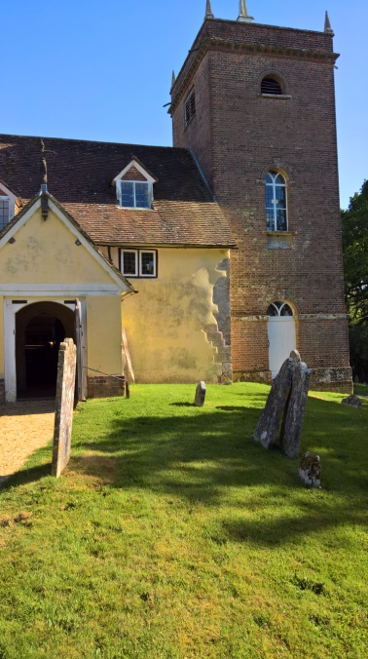
All Saints' Church, Minstead.
Notices - week commencing January 21st 2018

SERVICES

Sunday 21st 9.30am - Holy Communion.
Sunday 28th 10.30am - Service of the Word.

NEWS

Feb 9th and 10th, 7.30pm at St Michael's - "Radio Theatre" presents "Made in Cornwall". by Nigel Pascoe. This promises to be a very enjoyable evening; you will recognise many cast members as they are drawn from Minstead Players and the Vernon Theatre. Proceeds towards All Saints' Minstead Tower Repair Fund. Tickets £5, from Minstead Village Shop or Costa Coffee in Lyndhurst High Street.

COMPTON AREA
"Pictures and poems for Christmas."

CHARITY GIVING During January this church is supporting Minstead Training Trust. After services, you can make your donations using the special collection dish; found either at the church door or in the Compton area.

New Forest Basics Bank aims to provide support and help to individuals and families in need. The collecting box is in church. You are welcome to bring donations of non perishable food and hygiene items whenever the church is open, which will support those in need.

