All Saints’ Church, Minstead
Notices for the week commencing
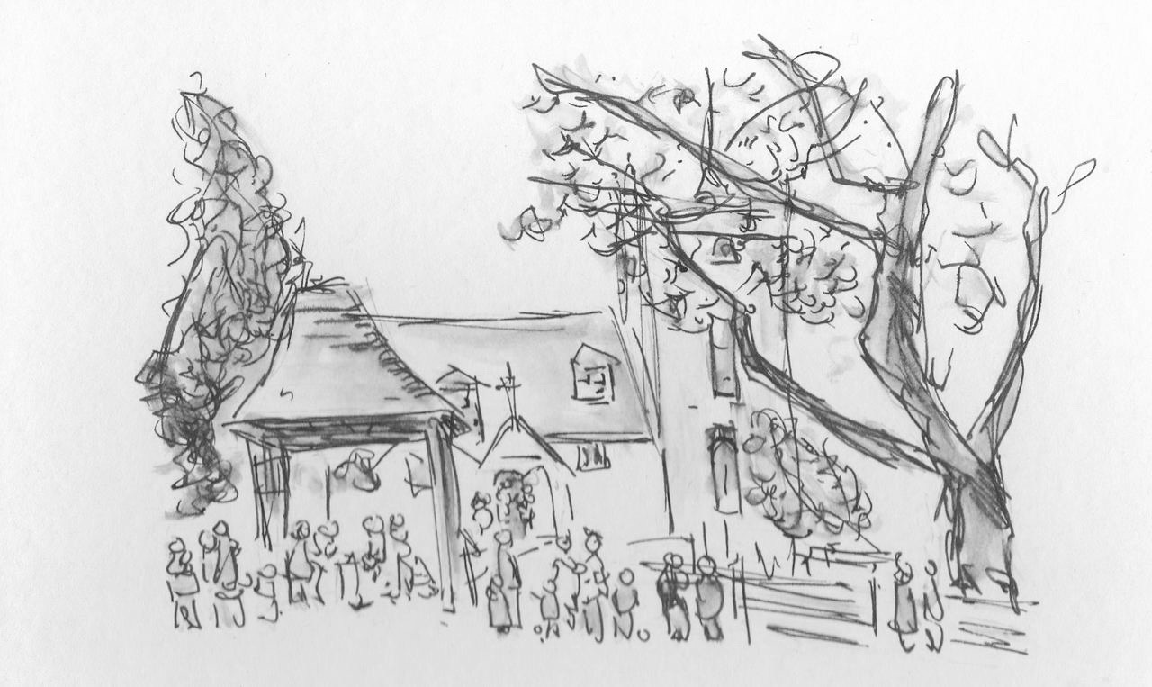
3rd June, 2018

SERVICES
Sunday, 3rd June: 9.30 Holy Communion Airborne Service
Sunday, 10th June: 6pm Evensong

NEWS
We are pleased to announce that the new Priest-in-charge for this Benefice will be Rev. David Potterton. Currently Assistant Curate at Romsey Abbey, he will take up the post here on August 20th and will be moving with his wife, Ann, into the
vicarage in Forest Gardens, Lyndhurst. As well as All Saints’, Minstead, he will look after Christ Church, Emery Down and St Michael’s, Lyndhurst. Arrangements for his Licensing Service at St. Michael’s on 21st August are in progress. On the day, short services will be held at All Saints’, Minstead and Christ Church, Emery Down immediately prior to the Licensing Service at St. Michael’s.
Church Wardens
Isabel Yeo 02380 282724
Elizabeth Randall 02380 811115

http://www.facebook.com/MinsteadChurch

http://newforestparishes.com

CHARITY GIVING
The PCC are looking for a Charitable Giving Coordinator to provide information about and generally promote our chosen charities.
During June we are supporting The Bible Society. After services, you can make your donations using the special collection dish, found either at the church door or in the Compton area.
New Forest Basics Bank aims to provide support and help to individuals and families in need. The collecting box is in church. You are welcome to bring donations of non perishable food and hygiene items whenever the church is open, which will support those in need.

Elizabeth Randall (02380 811115)
Isabel Yeo (02380 282724)
Churchwardens,
All Saints' Church, Minstead

https://www.facebook.com/MinsteadChurch
http://newforestparishes.com/
http://newforestparishes.com/about/minstead-church/calendar-2/

