Cadnam Safer Neighbourhoods Beat Report
1st – 31st May 2014
Safer Neighbourhoods team current priorities:
Our team priorities are set by our communities. We target the issues that you say are of concern to you and we work with colleagues and partner agencies to tackle local problems.

Our current priorities are tackling crime and Anti-social behaviour

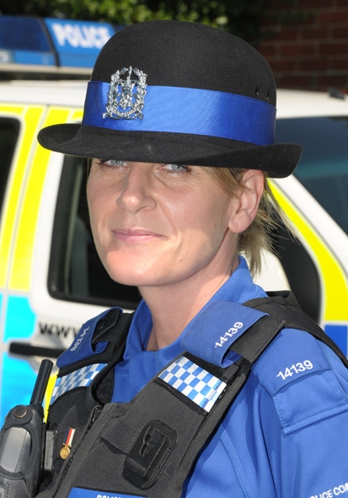
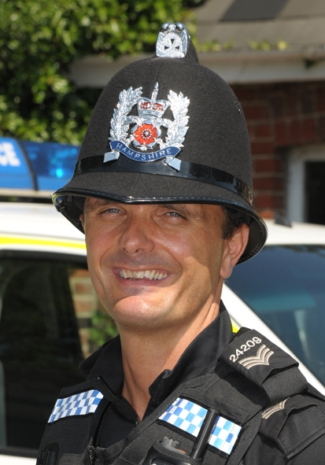
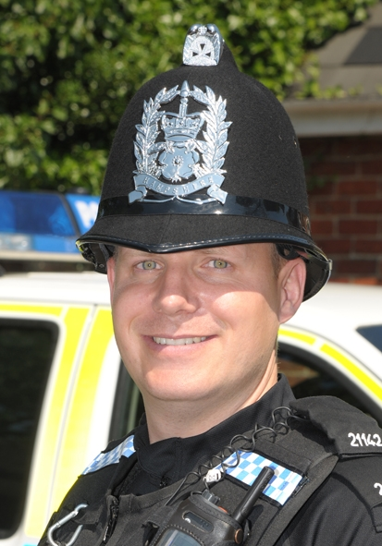

PC 21142 Rob Morant

PCSO 14139 Lisa Quinn

PS 24209 Paul Towler

Total incidents reported: 90, 24 of which were crimes

The other reported incidents related to information messages, suspicious incidents, driving complaints and other non-crime matters.

Anti-social behaviour – (6) There was report of littering in Bramshaw; four complaints in Bartley, three of which were noise related and a further noise nuisance in Winsor.

Assaults – (13) 12 occurred at a local hospital, one was domestic related.

Burglary – (0) With the lighter evenings be careful when leaving windows and doors open and please report any suspicious people you see.

Burglary (non dwelling) – (0) Please ensure outbuildings are locked and secured and contact local officers if you would like security and prevention advice.

Criminal Damage – (4) Two occurred at a local hospital, one at a local school and a vehicle was damaged following an altercation.

Drugs – (0)

Public Order – (0)

Road traffic collisions – (4) Two occurred on the A31, a dog was injured on the A337 and there was a collision in Ower.

Road traffic incidents – Fifteen people were summonsed for speeding offences; five in the Cadnam area and nine in Bramshaw and one in Minstead. A motorcyclist was also given a S59 warning for driving in an anti-social manner in Bartley.

Theft – (2) In separate incidents a trailer and a chainsaw were stolen in Cadnam.

Theft from vehicles – (2) Two vehicles were broken into in Forest car parks. Please ensure you secure your vehicle and remove all valuables.

Other events –
Totton Safer Neighbourhood Team
Crime prevention roadshow
Morrisons Supermarket , Totton
Friday 11th July
3pm-5pm

Speed watch – A total of 1497 vehicles were checked by Speed watch volunteers in May. Of those, 961 (64.2%) motorists were recorded exceeding the speed limit. Please get in touch with us if you would like further details regarding the recorded data and the action taken by police. Thank you to all involved in helping to make our villages safer. Please contact us if you would like details of how to volunteer.

Beat surgeries
If you have a matter you would like to discuss with us, beat surgeries are held the first Wednesday of every month –

Bramshaw Stores 0815-0915hrs
Minstead Stores 0930-1030hrs
Bartley Stores 1230-1330hrs
On alternatively call or email us at –
fordingbridge.snt@hampshire.pnn.police.uk
.

