VALENTINE’S EVENING at
MINSTEAD SOCIAL CLUB
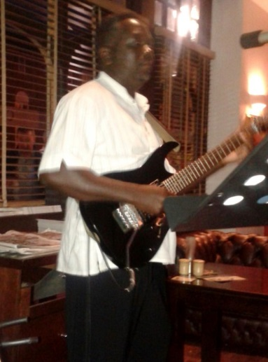
Saturday 14th February 2015
Open from 7pm
Featuring Romantic Music from
Reuben’s new Repertoire
BBQ food & Valentine cocktail available
JOIN US FOR A RELAXED FUN EVENING!
