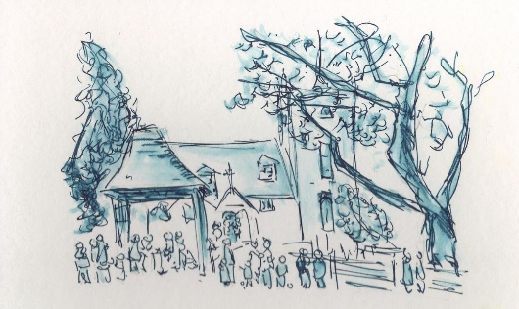
All Saints' Church, Minstead. Notices - week commencing January 20th, 2019.

SERVICES
Sunday 20th, 9.30am- Holy Communion
Sunday 27th, 10.30am – Service of the Word

NEWS and EVENTS
- Open Door Café. The next 4 dates are: Jan 31st, Feb 28th, March 28th, April 18th (Maundy Thursday). All Thursdays, between 2 and 4pm.
- To donate money to All Saints' by mobile text; The code for our church is ALLS01£ then you enter the amount 1,2,3,4,5 or 10 depending on how much you want to give. Text to 70070. For more info...see Peter, PCC treasurer.
- Benefice Taizé. Dates for Taizé services in all 3 churches have been arranged from this month until well into 2020. Please see posters and website, as well as weekly Benefice Notices.

COMPTON AREA - Exhibition of art work from Minstead Training Project.

CHARITY GIVING - During January, this church is supporting Minstead Training Trust. After services, you can make your donations using the special collection dish.

New Forest Basics Bank aims to provide support and help to individuals and families in need. The collecting box is in church. You are welcome to bring donations of non-perishable food and hygiene items whenever the church is open, which will support those in need.

